Master - Slave configuration

------------------------------------

Same version of java should exist.

Master and slave should have password less SSH

Step 1: Create slave machine , connect to slave

1) Update the apt repository

sudo apt-get update

2) sudo apt install openjdk-8-jdk -y

3) Check the Java Version

java -version

We need to establish password less connection between Dev server and Slave machine

Connect to slave

7) Check you user

$ whoami ( ubuntu )

8) set password for ubuntu user

syntax: sudo passwd <user_name>

Ex: sudo passwd ubuntu

enter password

$ cd /etc/ssh

$ ls ( we get list of files ) Look for sshd_config

To edit sshd_config

$ sudo vim sshd_config

Go to insert mode

change password authentication to yes

13) Save and quit :wq

14) Restart the service

$ sudo service ssh restart

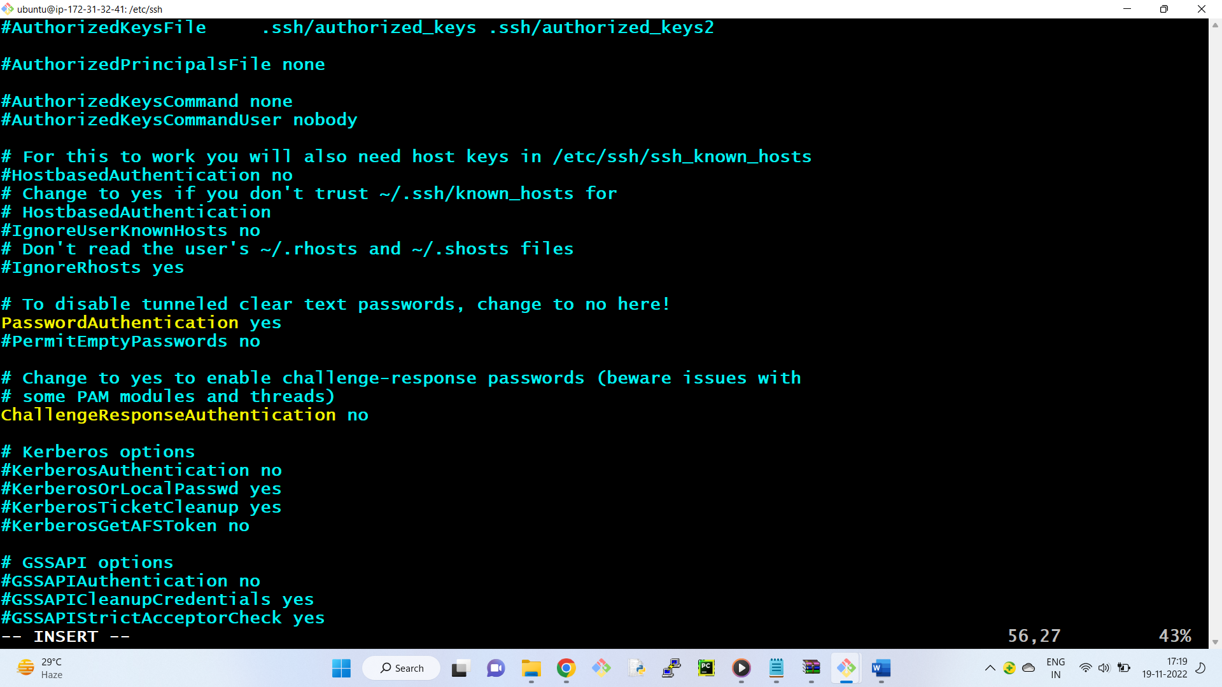

Lets test the connection

-------------------------------

15) Connect to the development server ( Master )

16) connect to slave server through dev server

ssh ubuntu@private_ip_slave_machine

$ ssh ubuntu@172.31.1.107

exit ( to come back to master )

+++++++++++++++++++++++++++++++++++++++

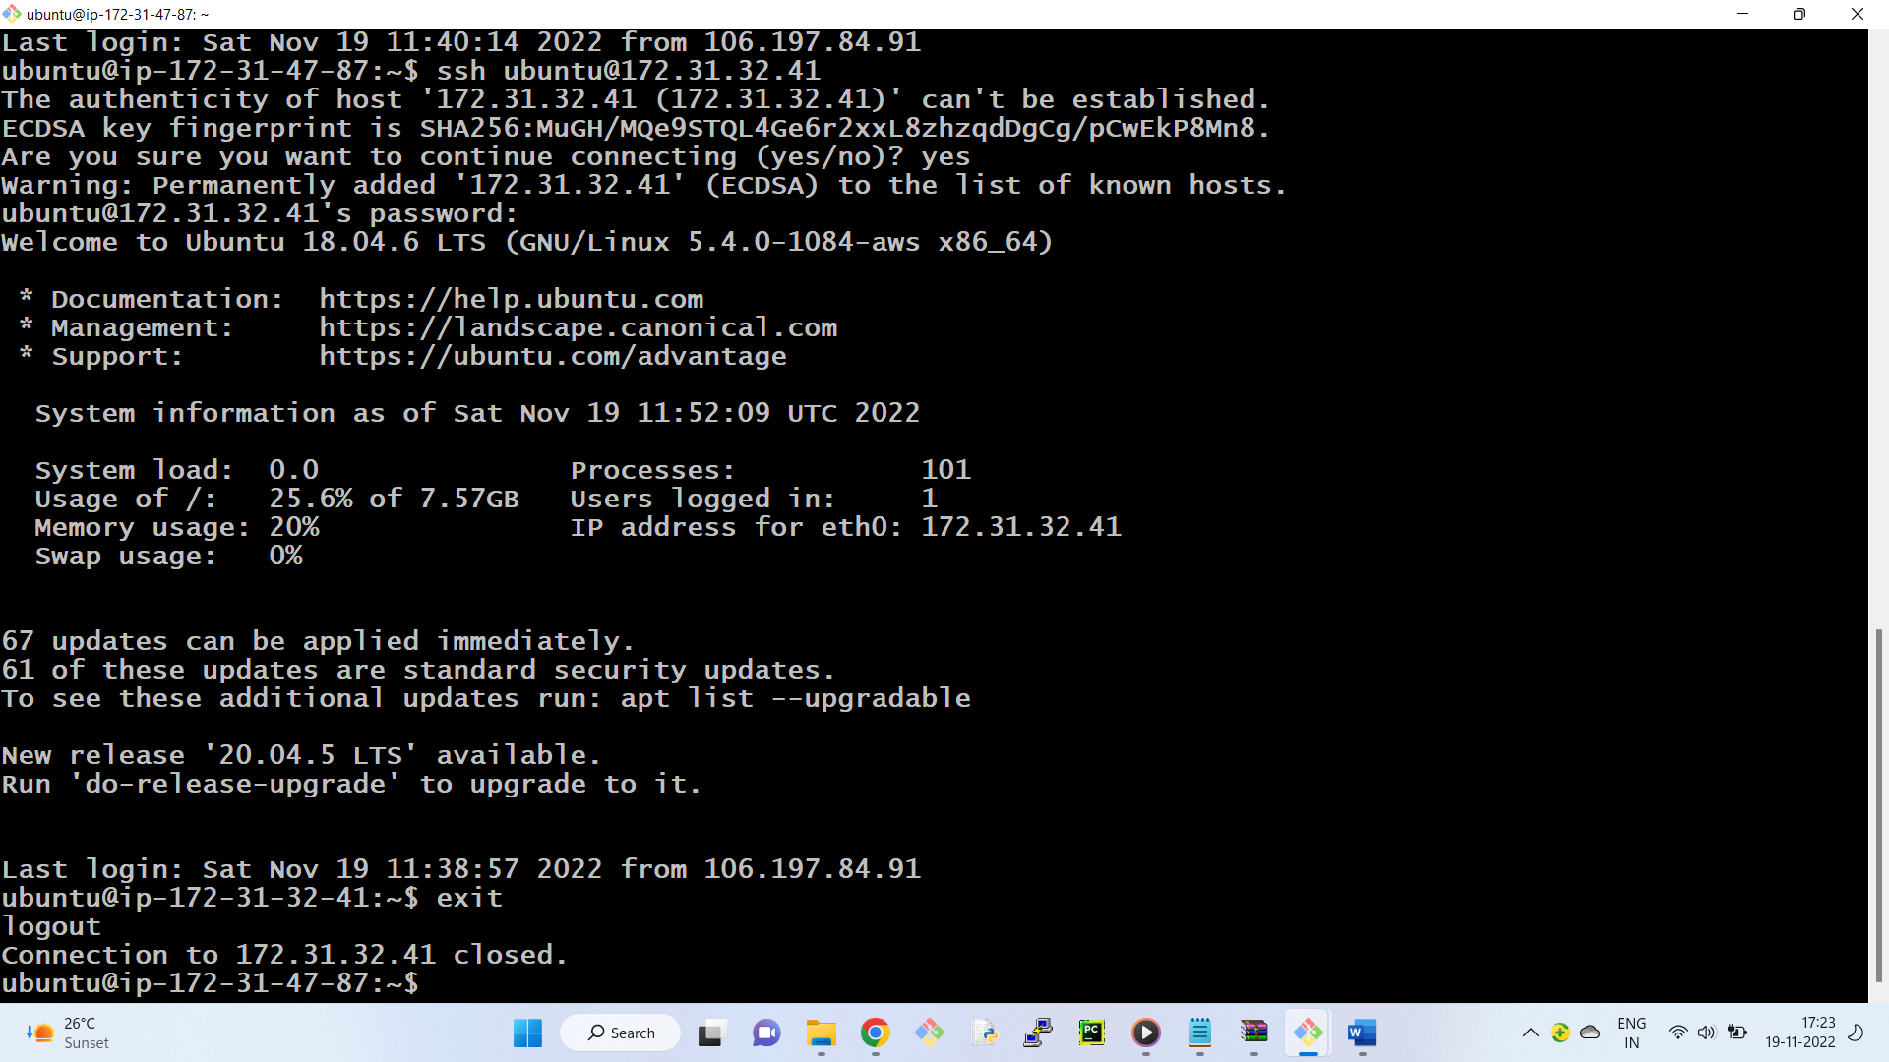

17) To connect to slave without password

$ ssh-keygen ( In master)

18) copy the keys to slave server

ssh-copy-id ubuntu@private_ip_slave_server

ssh-copy-id ubuntu@172.31.1.107

19) now we are able to connect to the slave user without password

$ ssh [ubuntu@172.31.1.107](mailto:ubuntu@172.31.1.107)

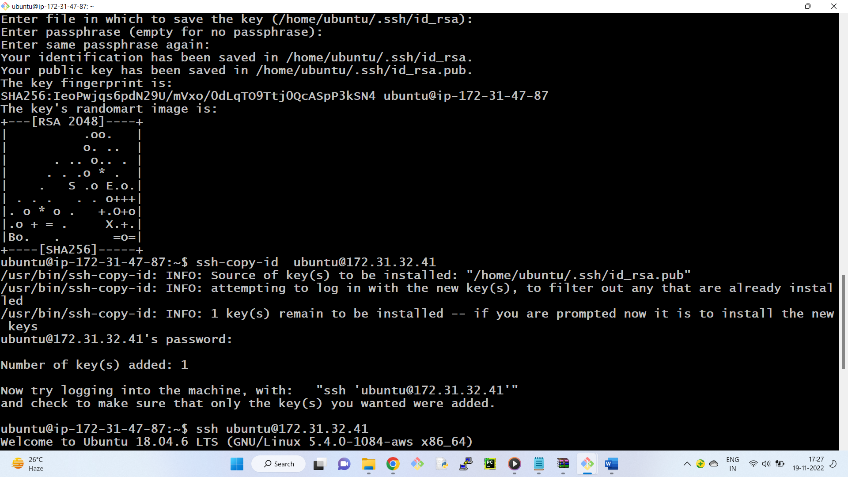

Download slave.jar in slave machine

sudo wget <http://devserverpvtip:8080/jnlpJars/slave.jar>

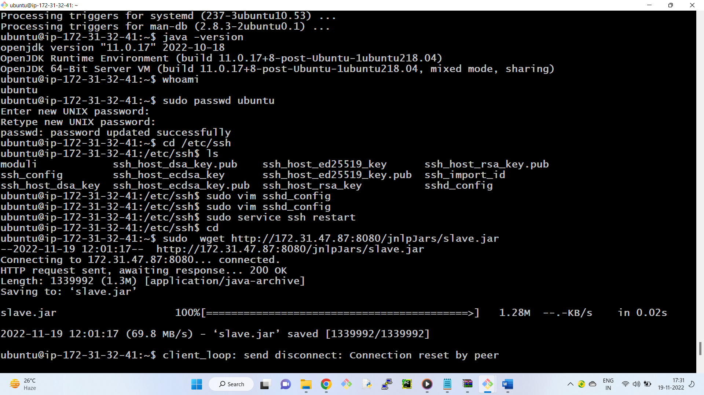

Check the file is download or not

$ ls

check the file permissions

$ ls -l

we want rwxr--r--

3) Give execute permissions of this file

sudo chmod u+x slave.jar

4) Create an empty folder which will work like workspace for jenkins to use on the slave machine

$ mkdir workspace

$ cd workspace

$ pwd ( note the path of the workspace )-- /home/ubuntu/workspace

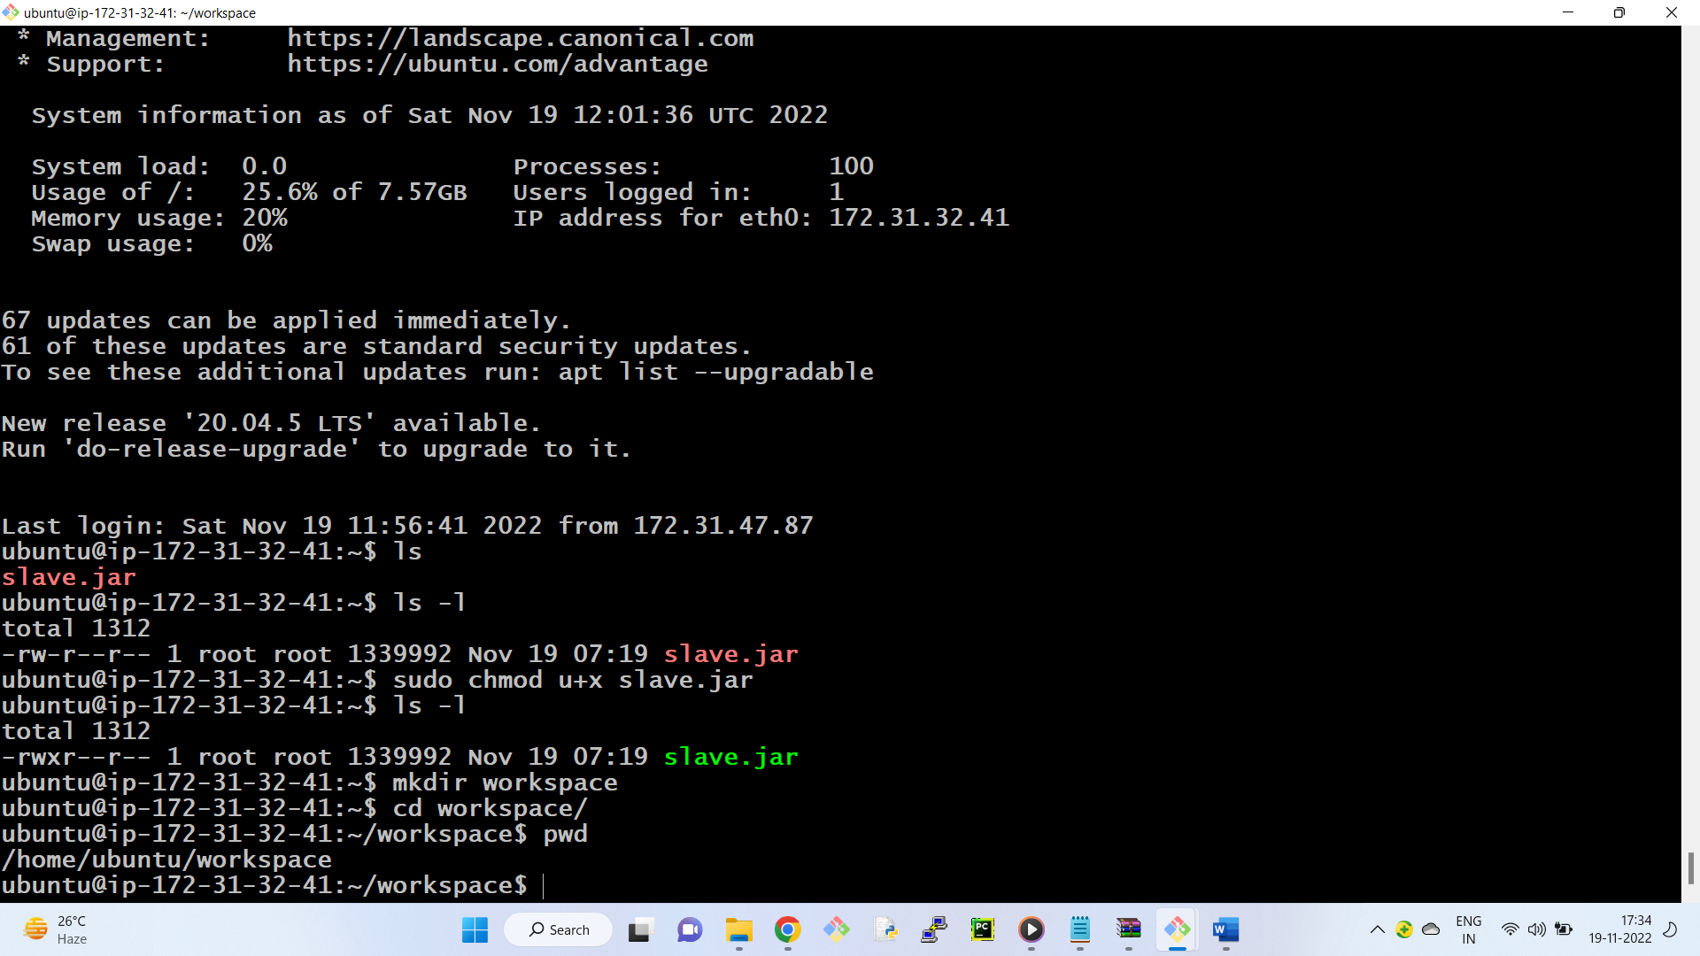

Creating node in Jenkins

---------------------------

Open the dashboard of jenkins

manage jenkins --- manage nodes

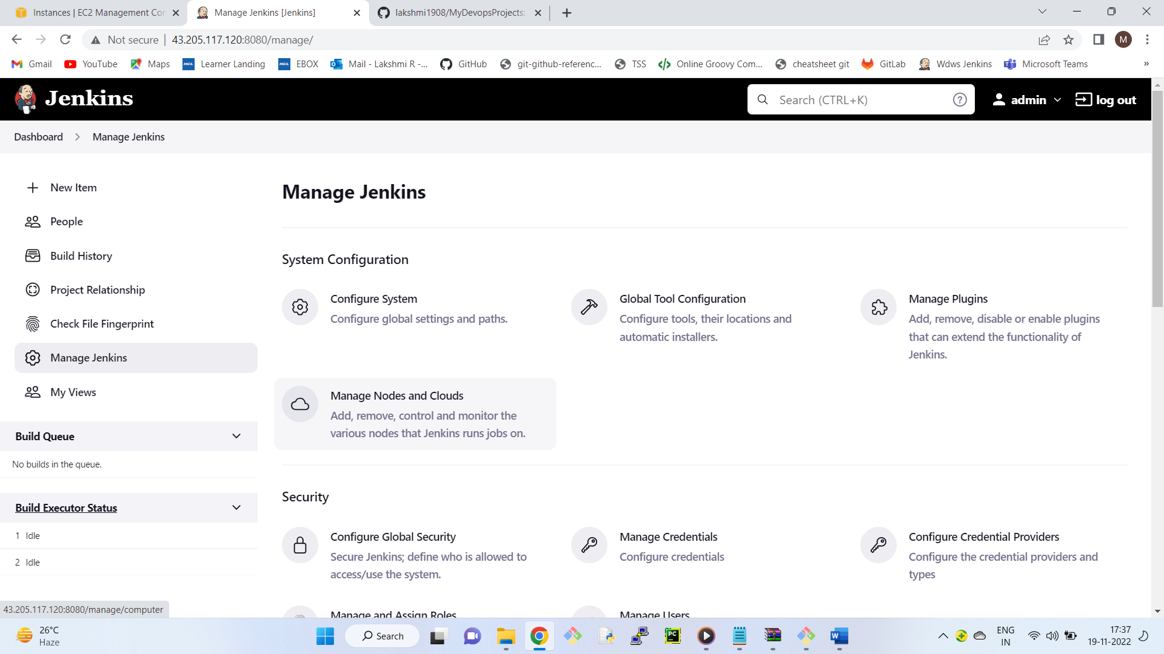

7) Click on new node ---- node name - Myslave

- select permanent agent

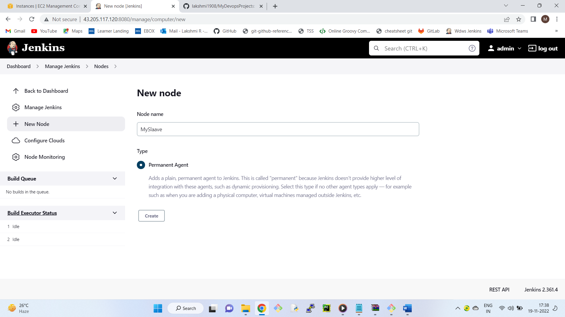

Remote root directory -/home/ubuntu/workspace

Label - Slave_lab

10) Go to Launch method

Select Launch agent via execution of command on the controller

11) In Launch command

ssh ubuntu@private_ip_of_slave java -jar slave.jar

ssh ubuntu@172.31.1.107 java -jar slave.jar

13) Click on save

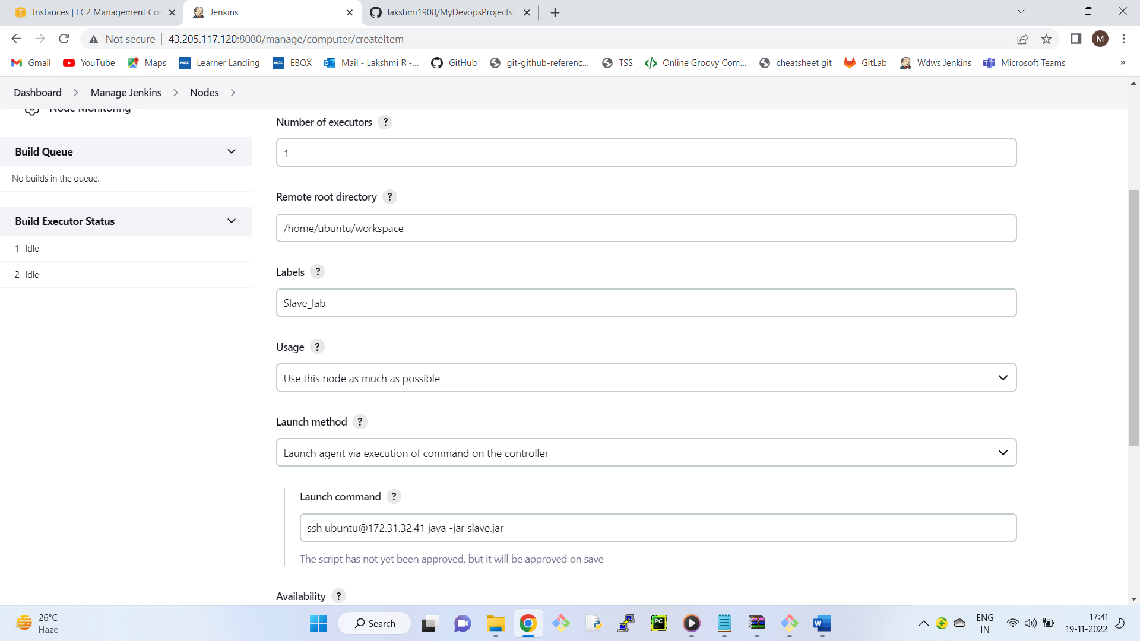

Configure job to run on slave

------------------------------

14) Select Testing Job

15) Go to Configure --> General Tab

17) Check Restrict where this project can be run

18) Enter Label Expression ( Slave_lab)

Apply ---> Save

Run the job, In console output, we can see the job is executed in slave machine

